Transportation Sales Tax Fund
Project Name:  Commercial Street Sidewalks | Department:  Public Works - Streets
Type of Project:  New Construction | Contact:  Chuck Soules
Total Project Cost:
$840,000

Description:
This project is the construction of a 6’ pedestrian sidewalk on Commercial Street, running from Smithville School District property north to Meadow Street in Downtown Smithville. The project will include a pedestrian sidewalk, ADA access, grading, curb and gutter, and pavement. The sidewalk will be approximately 4,500’ in length (nearly 1 mile). Pictured below is an image showing the project location in the City.
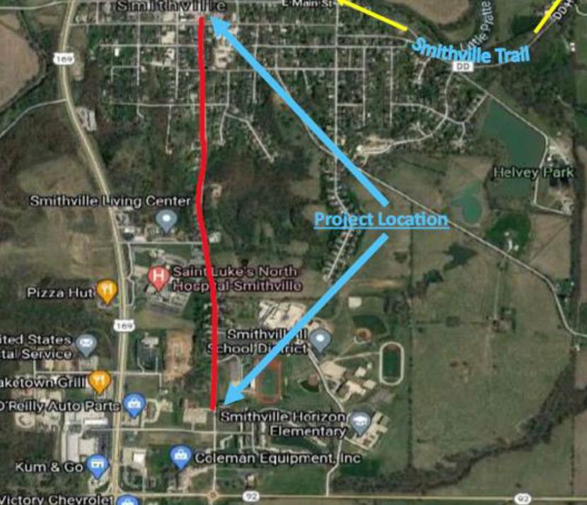
Justification:
Currently, there is sidewalk on only one side of Commercial Street. This additional sidewalk will not only allow for more pedestrian access for residents and visitors but also create more pedestrian access to the Smithville School District and encourage more students to walk or bike to school. The City received TAP (Transportation Alternatives Program) grant funding through MoDOT to offset project expenses.
Impact on Operating Costs:

The project will include the construction of a new sidewalk. There is the potential for future costs related to ongoing maintenance and upkeep of the pedestrian sidewalks, curbs, and gutter.

Planned Expenditures
 | FY2026 | Total
Construction | $840,000 | $840,000
Total | $840,000 | $840,000

Funding Sources
 | FY2026 | Total
Transportation Sales Tax | $840,000 | $840,000
MARC Funding | ($712,000) | ($712,000)
Total Net Cost | $128,000 | $128,000

